**Group Members:** Miguel Carmen

Michael Dugan

Mitchell Nuyens

Kayla Osburn

**Course:** ENGR 114, Fall 2019

**Date:** 12/9/2019

**Revision:** 3

**“Automatic” Blinds**

***Problem Statement****:*

As we were thinking of a problem in the world, we came up with many ideas, but we came up with one that can be very beneficial for many college students, and anyone needing to save money on heating. This project consists of building a system that opens the blinds, up and down depending on the light intensity and user input. So when the sun rises and the user inputs a command, the blinds rise. Not only letting you wake up with the sunrise but starts letting sun in for a natural and free way to heat up your room or house without you having to get up. This has the potential to help one's mental health as the light-induced effects of serotonin are triggered by sunlight that goes in through the eye. Sunlight cues special areas in the retina, which triggers the release of serotonin. Our main focus is to build the system using the sunlight. Concluding that the system will open or close the blinds automatically depending on the light intensity and user command.

***Hardware Setup****:*

We used a SparkFun RedBoard logic board, breadboard, a SparkFun EasyDriver motor driver board, a Bipolar Stepper Motor, an LDR (light dependent resistor) and an LED. The LDR outputs an analog value that is then interpreted into a digital command via the logic board. Through the driver board, this command spins the motor either direction for a certain number of steps. The LED was used for initial testing of the LDR and is currently used to indicate the activation of the motor.

When plugged into a computer, the logic board is powered by the 5V USB. When the system is independent of the computer, it is powered by the 12V wall transformer. The driver runs off of this power regardless of the computer connection.

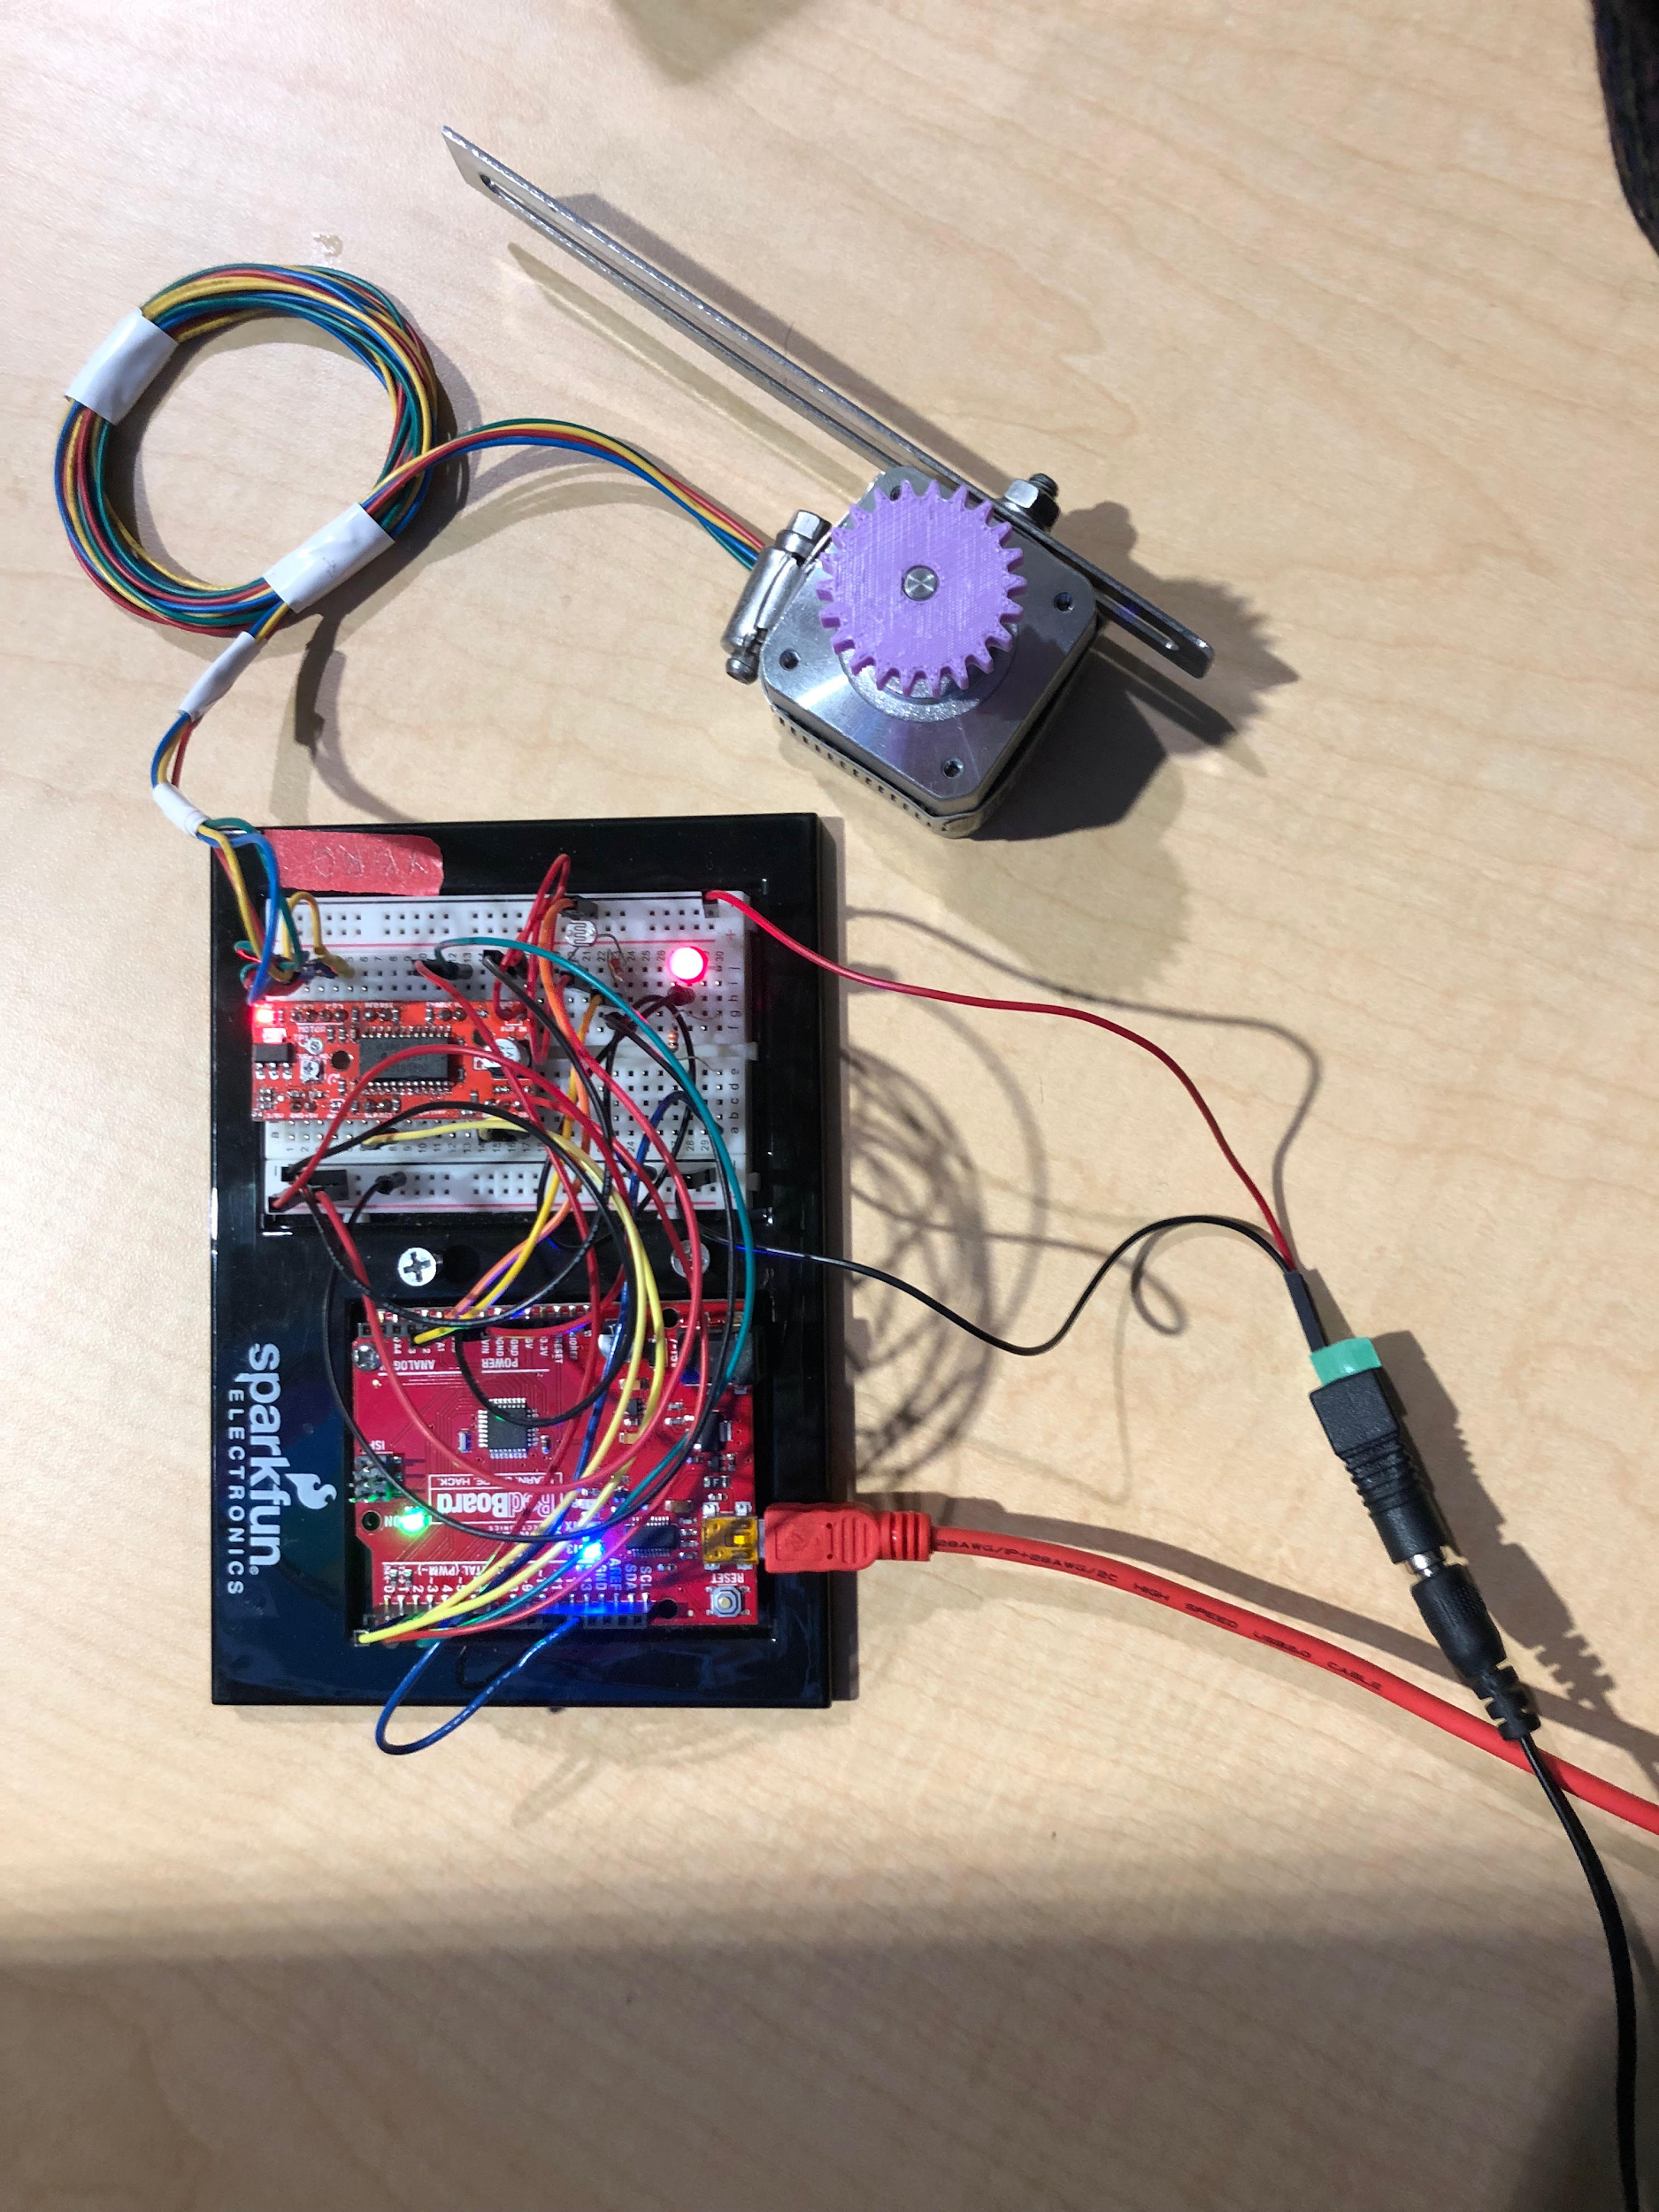

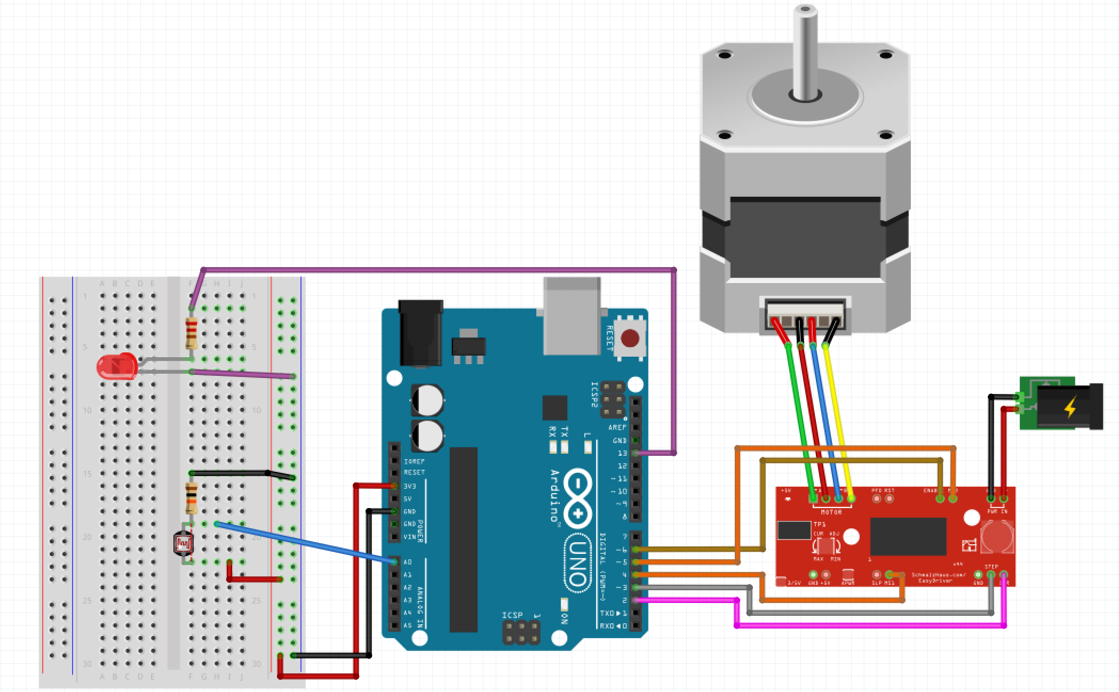

***Arduino Code:***

// Declare pin functions on RedBoard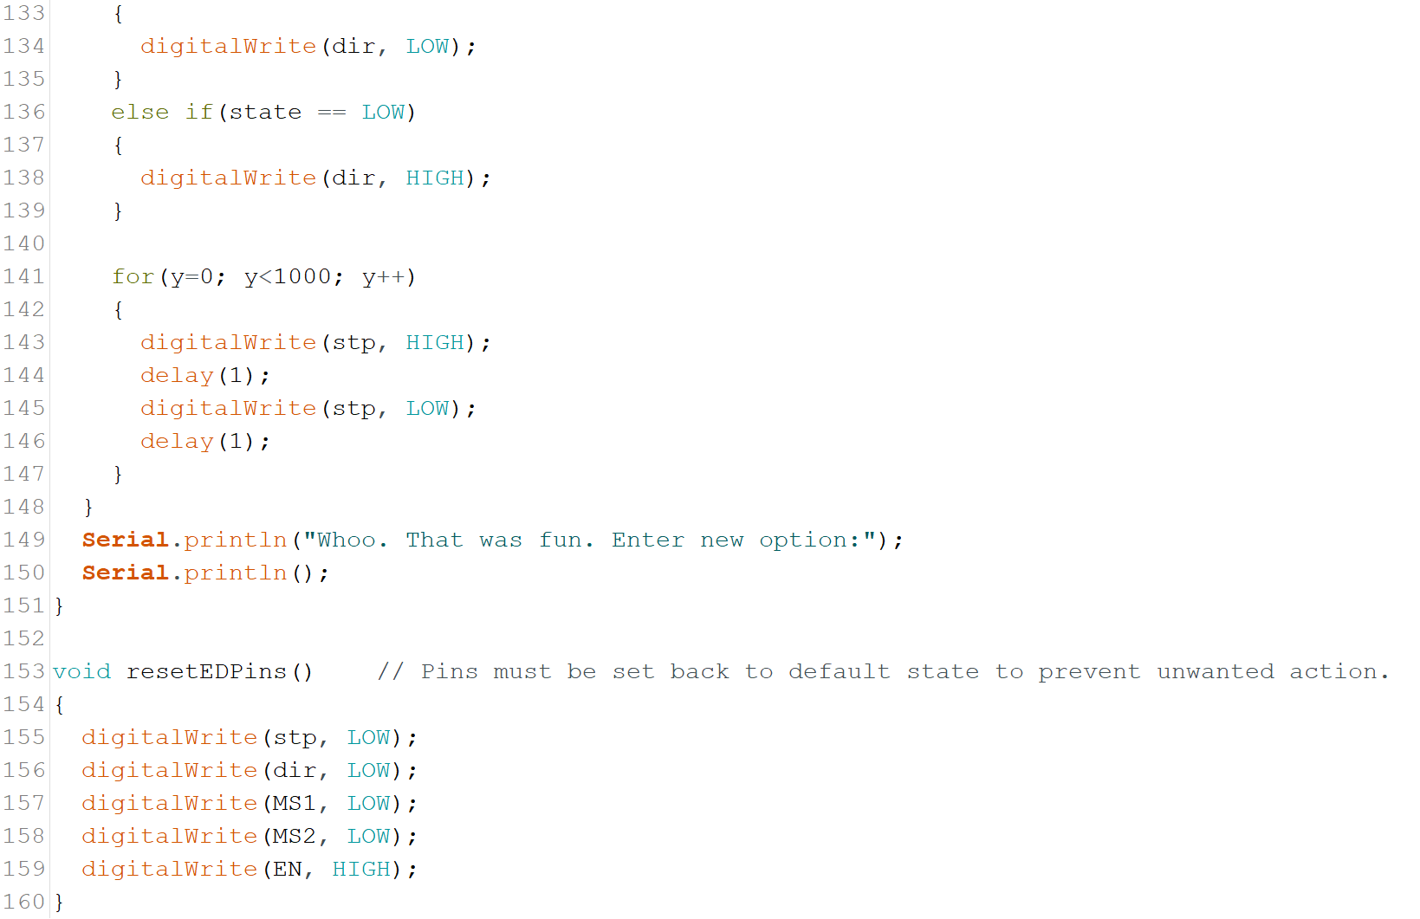

#define stp 2

#define dir 3

#define MS1 4

#define MS2 5

#define EN 6

#define speedDelay 1

#define HEIGHT 18000

//Declare variables for functions

int sensorPin = A0; // select the input pin for ldr

int sensorValue = 0; // variable to store the value coming from the sensor

char user_input; // for motor function communication

int x;

int y;

int state;

void setup() {

// digital pins on Arduino are either input/output.

/// we want to send data to the driver, so we choose output.

pinMode(13, OUTPUT); //pin connected to the led

pinMode(stp , OUTPUT); // voltage to motor

pinMode(dir, OUTPUT); // polarity of motor voltage

pinMode(A0, INPUT_PULLUP); // pull-up resistor / signal from LDR

// resetEDPins(); // Set step, dir, ms1/2 and en pins to default states

// set an initial value of low to both our step and dir pins (FALSE or 0 are also acceptable)

digitalWrite(stp, LOW);

digitalWrite(dir, LOW);

Serial.begin(9600); // sets serial port for communication

Serial.println("1. Automatic Function");

Serial.println("2. Roll shade up");

Serial.println("3. Roll shade down");

Serial.println("4. Show off");

Serial.println();

}

void loop() {

while(Serial.available())

{

user_input = Serial.read(); // Read user input and trigger a function

digitalWrite(EN, LOW); // Pull enable pin LOW to allow motor control

if (user_input == '1')

{

LightActivated();

}

else if(user_input == '2')

{

StepForwardDefault();

}

else if(user_input =='3')

{

ReverseStepDefault();

}

else if(user_input =='4')

{

ForwardBackwardStep();

}

else

{

Serial.println("Invalid option entered.");

resetEDPins();

}

resetEDPins();

}

}

void LightActivated() {

delay(2000);

Serial.println("Reading LDR Output");

sensorValue = analogRead(sensorPin);

Serial.println(sensorValue);

delay(200);

if (sensorValue > 200 )

{

digitalWrite(dir, LOW); // Pull direction pin LOW to move CW/'forward'

for(x=0; x<HEIGHT; x++) // ADJUST FOR HEIGHT OF SHADE!!

{

digitalWrite(stp,HIGH); // Trigger one step forward

delay(1);

digitalWrite(stp,LOW); // Pull step pin low so it can be triggered again

delay(1);

}

}

else

{

Serial.println("It's dark outside. No action taken.");

delay(200);

}

Serial.println("End Function.");

}

void StepForwardDefault()

{

Serial.println("Moving forward at defaul step mode.");

digitalWrite(dir, LOW); // Pull direction pin LOW to move CW/'forward'

for(x=0; x<HEIGHT; x++) // ADJUST FOR HEIGHT OF SHADE!!

{

digitalWrite(stp,HIGH); // Trigger one step forward

delay(speedDelay);

digitalWrite(stp,LOW); // Pull step pin low so it can be triggered again

delay(speedDelay);

}

Serial.println("Hello, world! Enter new option:");

Serial.println();

}

void ReverseStepDefault()

{

Serial.println("Moving in reverse at default step mode.");

digitalWrite(dir, HIGH); // Pull direction pin HIGH to move CCW/'reverse'

for(x=0; x<HEIGHT; x++) // ADJUST FOR HEIGHT OF SHADE!!

{

digitalWrite(stp,HIGH);

delay(speedDelay);

digitalWrite(stp,LOW);

delay(speedDelay);

}

Serial.println("Throwing shade up in here. Enter new option:");

Serial.println();

}

void ForwardBackwardStep()

{

Serial.println("Alternate between stepping forward and reverse.");

for(x=1; x<100; x++) // ADJUST SO IT DOESN'T MAX OUT ON EITHER END!!

{

// Read direction pin state and change it

state = digitalRead(dir);

if(state == HIGH)

{

digitalWrite(dir, LOW);

}

else if(state == LOW)

{

digitalWrite(dir, HIGH);

}

for(y=0; y<100; y++)

{

digitalWrite(stp, HIGH);

delay(speedDelay);

digitalWrite(stp, LOW);

delay(speedDelay);

}

}

Serial.println("Whoo. That was fun. Enter new option:");

Serial.println();

}

void resetEDPins() // Pins must be set back to default state to prevent unwanted action.

{

digitalWrite(stp, LOW);

digitalWrite(dir, LOW);

digitalWrite(MS1, LOW);

digitalWrite(MS2, LOW);

digitalWrite(EN, HIGH);

}

***Python Code:***

# shade_func.py

import serial

import time

def shade():

"""

The shade() function is designed as a first prototype in the pursuit of designing a completely autonomous window blind.

It's purpose is to analyze the outside light sources and assess whether the outside world is worthy of the user's viewing.

If it is dark (sensorValue < 50), the motor will not pull up the blinds.

If it is bright (sensorValue > 50), the motor will roll up the blinds to reveal the beautiful world outside!

(edit: assumptions made about user's personal view are not the responsibility of this function. shade() is not responsible for

things that can not be unseen once blinds are open.)

"""

ser = serial.Serial('COM3', 9600)

time.sleep(2)

print(' PLEASE START WITH WINDOW CLOSED ')

print('1. Automatic Function (Light Detection)')

print('2. Roll shade up')

print('3. Roll shade down')

print('4. Show off a little')

print('5. Quit')

user_input = input('Enter a numeric option: ')

while(user_input == '1' or '2' or '3' or '4' or '5'):

if user_input == '1':

ser.write(b'1')

print('> DEVICE IS ASSESSING IF OUTSIDE WORLD IS WORTHY OF YOUR VIEWING')

time.sleep(2)

print('>> ARDUINO HAS DECIDED.')

time.sleep(3)

user_input = input('Enter a numeric option: ')

elif user_input == '2':

ser.write(b'2')

print('> MANUALLY ROLLING UP IN HERE')

time.sleep(30)

user_input = input('Enter a numeric option: ')

elif user_input == '3':

ser.write(b'3')

print('> MANUALLY THROWING SHADE')

time.sleep(30)

user_input = input('Enter a numeric option: ')

elif user_input == '4':

ser.write(b'4')

print('> CHECK OUT MY DANCE MOVES')

time.sleep(5)

print('> ALRIGHT, ENOUGH OF THAT')

time.sleep(1)

user_input = input('Enter a numeric option: ')

elif user_input == '5':

ser.write(b'5')

print('> Function has been terminated. Goodbye.')

break

else

print('> Input was not recognized. Try again.')

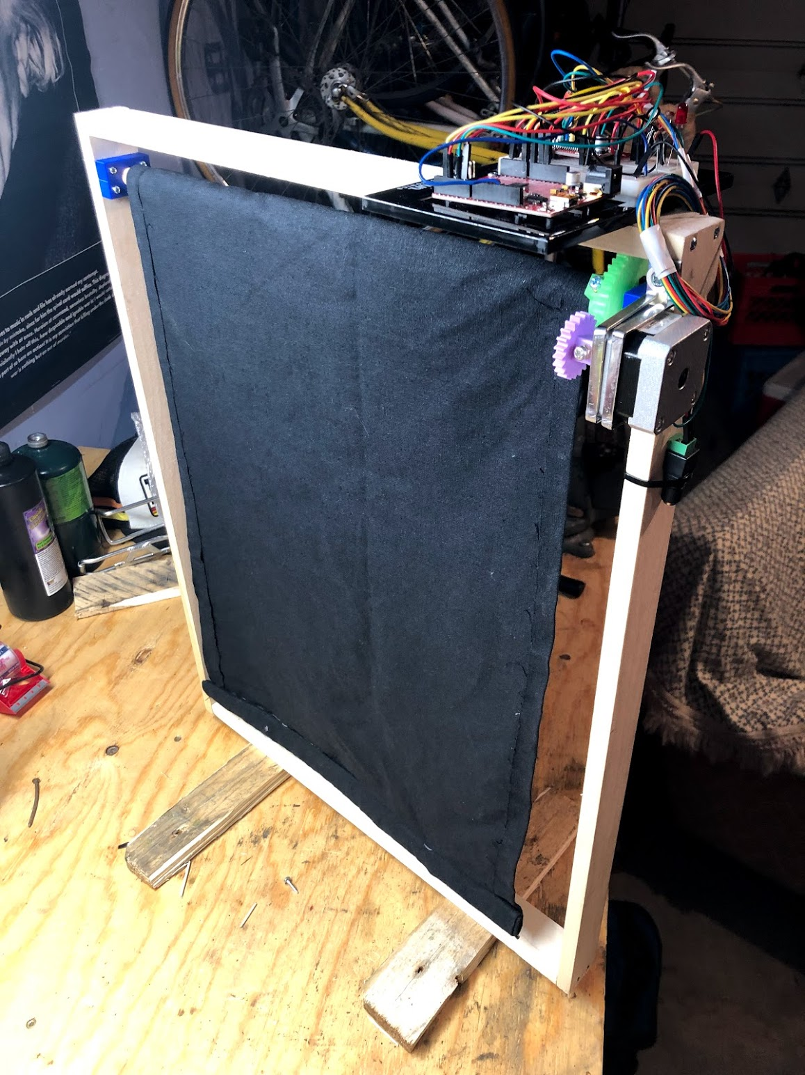

ser.close()

print('PROGRAM END')

***Results:***

The user can input one of five options and see an outcome from the device. The motor is moving as fast as it can with the current code, but this actually plays to the advantage of the device. By moving slowly, the shade is subtle and preserve the tranquility of its environment. The user can also manually activated the functions of the shade.

It’s currently a stand-alone shade that requires the connection to a power source and to the computer to capture user input.

***Future Work:***

If students wanted to recreate this project and not only obtain what we've accomplished so far but as well as build upon it since what we have done is a prototype, there’s a couple of ideas what would be cool to try. For starter’s one would be to have a blind that does not need user input but just a stand alone unit blind opener based on sunlight. Another option would be a timer for a certain time of the day to open and close. Lastly an app oriented controller that lets you control them even when you aren't home.

For future students who attend Portland Community College, some resources that we found to be very useful was the maker lab at Sylvania. The Maker lab had an immense abundance of resources such as 3D printers, building supplies and help from some really smart higher level students and professors. Of course, another one is the web, we did find a project similar enough to ours that gave us a brief idea of what we needed to do. The internet was very helpful especially Sparkfun that helped with the hardware part and connecting an arduino but definitely the best resource was the Maker lab and the engineering lab. So our best advice would be getting help and taking advantage of the great resources provided to you by this college.

To add on to the future work, we wanted to share some of the mistakes and complications we had in hopes to help other students try to avoid those problems. The first one would be not utilizing the resources sooner than we ended up doing. The Maker lab played a huge part in the creation of our project and we probably would’ve experienced a lot less stress if we went sooner. Another complication was having no previous Arduino coding knowledge and choosing a project that would be considered ambitious by some novices.

***License:***

Copyright 2019 Miguel Carmen, Michael Dugan, Mitchell Nuyens, Kayla Osburn

Permission is hereby granted, free of charge, to any person obtaining a copy of this software and associated documentation files (the "Software"), to deal in the Software without restriction, including without limitation the rights to use, copy, modify, merge, publish, distribute, sublicense, and/or sell copies of the Software, and to permit persons to whom the Software is furnished to do so, subject to the following conditions:

The above copyright notice and this permission notice shall be included in all copies or substantial portions of the Software.

THE SOFTWARE IS PROVIDED "AS IS", WITHOUT WARRANTY OF ANY KIND, EXPRESS OR IMPLIED, INCLUDING BUT NOT LIMITED TO THE WARRANTIES OF MERCHANTABILITY, FITNESS FOR A PARTICULAR PURPOSE AND NONINFRINGEMENT. IN NO EVENT SHALL THE AUTHORS OR COPYRIGHT HOLDERS BE LIABLE FOR ANY CLAIM, DAMAGES OR OTHER LIABILITY, WHETHER IN AN ACTION OF CONTRACT, TORT OR OTHERWISE, ARISING FROM, OUT OF OR IN CONNECTION WITH THE SOFTWARE OR THE USE OR OTHER DEALINGS IN THE SOFTWARE.